1: Watch the video and write down notes.

Done.

2: MFA for aws account

MFA Configured for AWS console account as shown in below SS

3: Install aws cli in windows.

Downloaded Aws CLI you can see in the below SS

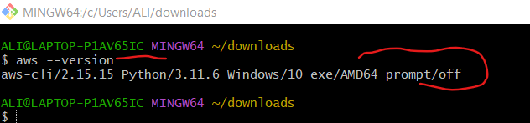

4: Setup ec2 in N.virginia region using aws cli command.

Configuring AWS to CLI with access key

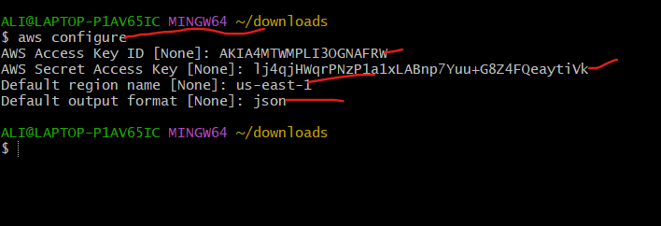

Created Instance with CLI Command marked as green

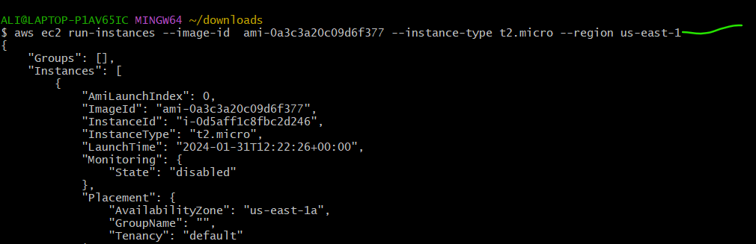

You can see in below SS it is created and running successfully



5: Setup security group in ohio region with name - Techie-sg and open port 22

Created security group using CLI named as Techie-sg as shown In below SS

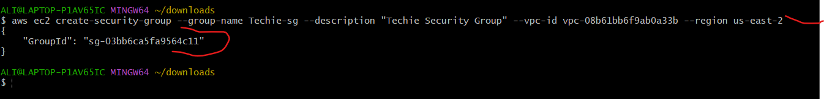

Configured at port no 22

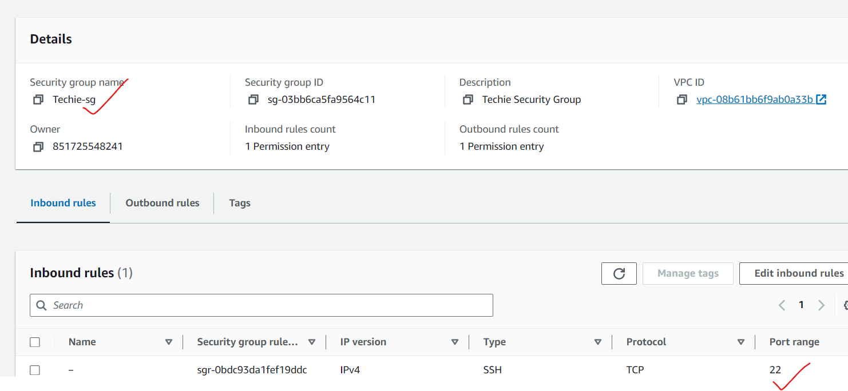

6: setup ec2,security group in Mumbai region using single aws cli command.

Created security group in Mumbai by using CLI command as show in SS

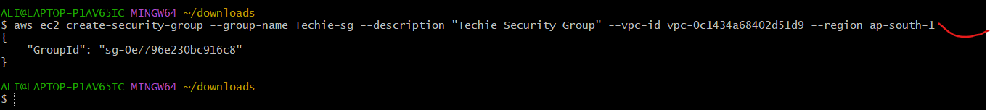

It is running on port no 22

